**Municipality Events Application**

**Amante, Grifaith**

**Camance, Paul Dwight**

**Dacaymat, Einstien**

**Meniano, Cyrus Jasper**

**Salvo, Feb Josh**

**An Object-Oriented Programming Project**

Department of Information Technology

College of Engineering and Technology

University of Science and Technology of Southern Philippines – Claveria Campus

Claveria Misamis Oriental, 9004 Philippines

December 16, 2024

1. **Background of the Study**

Misamis Oriental boasts a rich cultural heritage and a vibrant community life. However, it currently lacks a centralized platform for disseminating information about the numerous events occurring across its cities and municipalities. This deficiency results in reduced community engagement and missed economic opportunities, particularly within the tourism and event-dependent sectors (Gonzales, 2020).

The Municipality Events Application aims to address this issue by providing a comprehensive and user-friendly platform for consolidating event information. Its objectives include enhancing community participation, promoting local economic development, and ensuring broad accessibility across various devices. By offering real-time updates and serving as a reliable source for local events, the application will bridge communication gaps, preserve cultural heritage, foster social cohesion, and leverage digital transformation for regional advancement. This initiative is essential for fostering a more informed and engaged community, ultimately contributing to the sustainable growth and development of Misamis Oriental.

1. **Objectives**

**Centralize Event Information:**

* Gather and display all events from the municipalities of Misamis Oriental in one easy-to-access platform.

**Promote Community Engagement:**

* Foster a sense of connection within the community by showcasing local events and activities.

**Provide Real-Time Updates:**

* Keep users informed about the latest events, changes, or updates in real time.

**Support Cultural Tapestry of Misamis Oriental:**

* Reflect and promote the region’s vibrant culture by featuring a variety of local events and experiences.

**Encourage Regional Tourism:**

* Attract visitors to Misamis Oriental by showcasing the rich variety of events and experiences the region has to offer.

1. **Scope and Delimitation of the Study**

**Scope:**

1. **Event Coverage:**
   * MIO will display events organized by municipalities within Misamis Oriental, including cultural festivals, community gatherings, concerts, sports events, and other local activities.
2. **Target Audience:**
   * The app is designed for both residents and visitors to Misamis Oriental, providing easy access to event information and updates.
3. **Real-time Update:**
   * The app will provide real-time updates on events, including changes, cancellations, or new additions. Users will receive notifications for upcoming events they are interested in.
4. **User Interaction:**
   * MIO will allow users to interact with event listings by browsing events or municipalities, view event details and pinning events.

**Delimitation:**

1. **Geographical Limitation:**
   * The app is focused solely on events within the municipalities of Misamis Oriental. Events outside this region will not be included in the platform.
2. **Event Types:**
   * MIO will primarily feature public events organized by local municipalities, not private or invitation-only events.
3. **Event Information:**
   * The accuracy and timeliness of event information will depend on the data provided by local municipalities and event organizers. MIO does not have control over event details beyond what is submitted to the platform.
4. **Language and Accessibility:**
   * While MIO will support multiple languages, the primary language of the app will be Filipino and English. The availability of event details in other languages will depend on individual event organizers.
5. 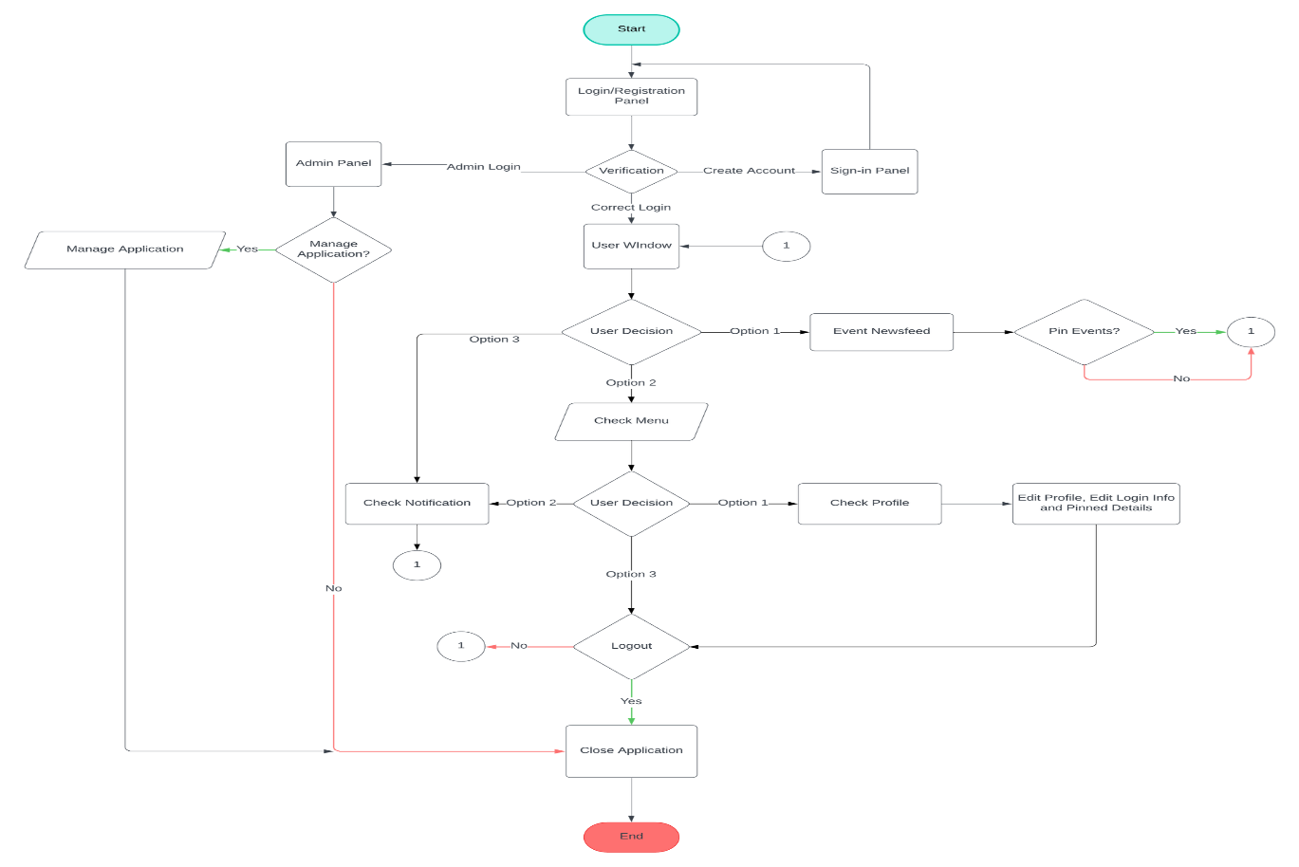**Flowchart**

Figure 1: Flowchart

This data flow diagram illustrates the proposed system for tracking events, transitioning from manual processes to an application-based approach with a centralized database and login system. Event details are documented and stored digitally by officials within the centralized database. Users access the system through a secure login, allowing them to retrieve event information efficiently via the application. This modernized system enhances the accuracy, accessibility, and management of event data compared to the previous manual methods.

1. A graph with different colored squares

   Description automatically generated**Gantt Chart**

Figure 2: Gantt Chart

This Gantt chart illustrates the timeline of a project spanning from September to December 2024, detailing key tasks and their durations. It begins with Concept & Planning in early September, followed by Project Scoping in mid to late September. Design occurs from late September to mid-October, with a brief continuation in early November. Development spans from early October to mid-November and resumes in late November to early December. Testing takes place from mid to late November and again in early December, culminating in the project's Launch in early December. This chart visually represents the overlaps and sequential flow of these project phases.

1. 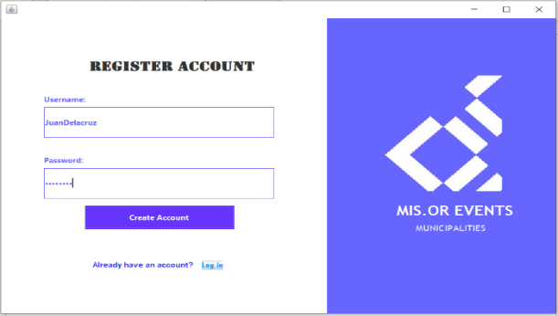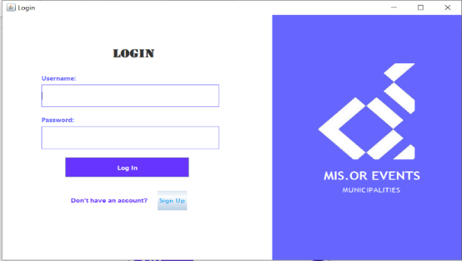**System Design**

Figure 4: Registration Panel

Figure 3: Login Panel

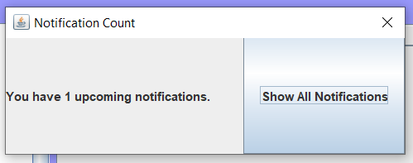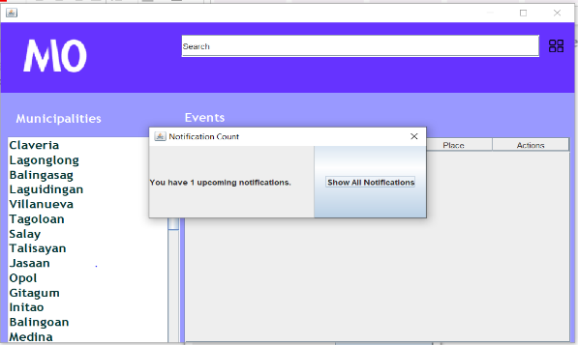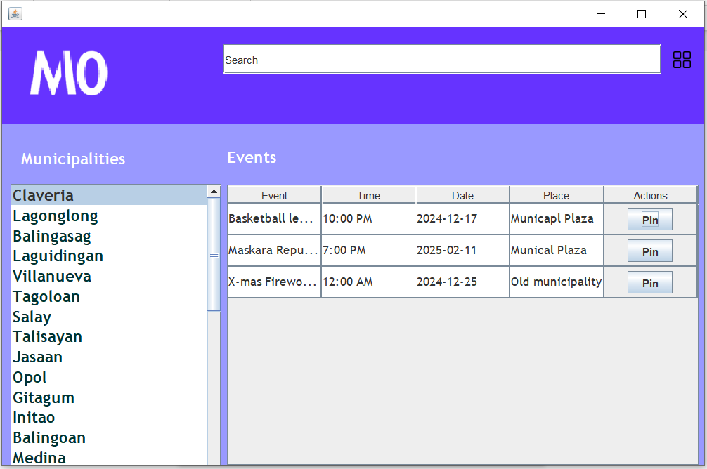The Municipality Events App for Misamis Oriental is a user-friendly platform designed to facilitate the exploration and management of local events. The system features a login (figure 3) and register (figure 4) interface as the main access point, providing fields for username and password, along with a "Log In" button and a sign-up option for new users. The design is minimalistic, incorporating the application's branding through a prominently displayed logo and name.

Figure 6 & 8: City List & Notification Reminder

Figure 5 & 7: Notification Panel

Upon successful login, a notification will pop if there is an upcoming pinned event (figures 5 and 7) clicking the “Show All Notification” will show all pinned events notification (figure 8). The events management interface enhances the user experience by allowing event exploration through a scrollable list of municipalities within Misamis Oriental (figure 6). It includes a search bar for efficient retrieval of specific events and a well-structured table that displays event details such as name, time, date, location, and available actions, such as pinning or registration.

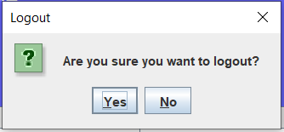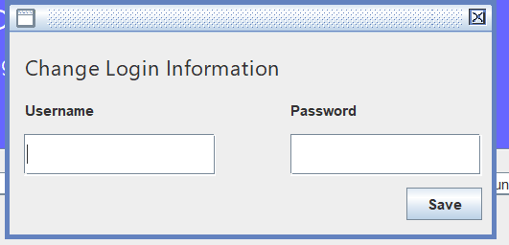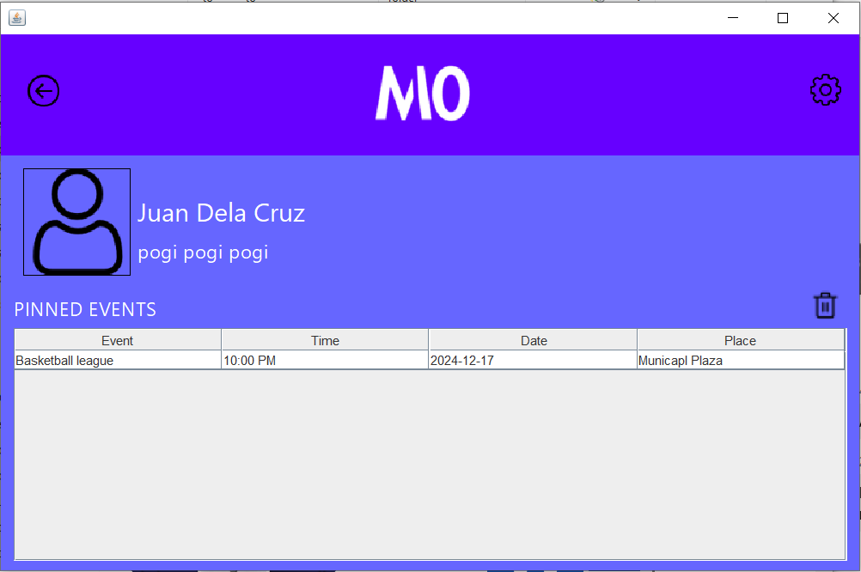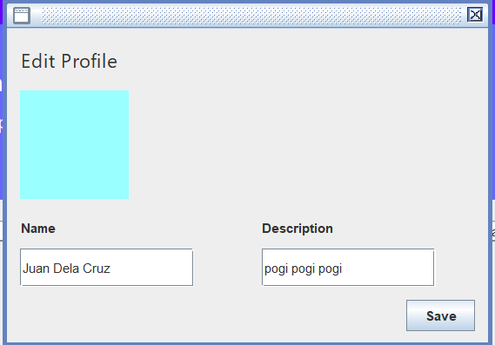

Figure 10: Menu Options

Figure 13: Logout Panel

Figure 12: Account Settings

Figure 11: Edit Profile Panel

Figure 9: Table of Pinned Events

Users are directed to a personalized dashboard that displays their name and a table of pinned events (figure 9). This table includes details such as event name, time, date, and location, as well as options to manage pinned events, including deletion. Additionally, a settings icon (figure 10) is available to access user-specific configurations. By clicking the settings icon, users can locate the edit profile (figure 11) and account settings (figure 12) Notification, and Logout (figure 13). The application’s clean and intuitive layout ensures a streamlined process for users to discover, organize, and participate in events relevant to their preferences.

Figure 12

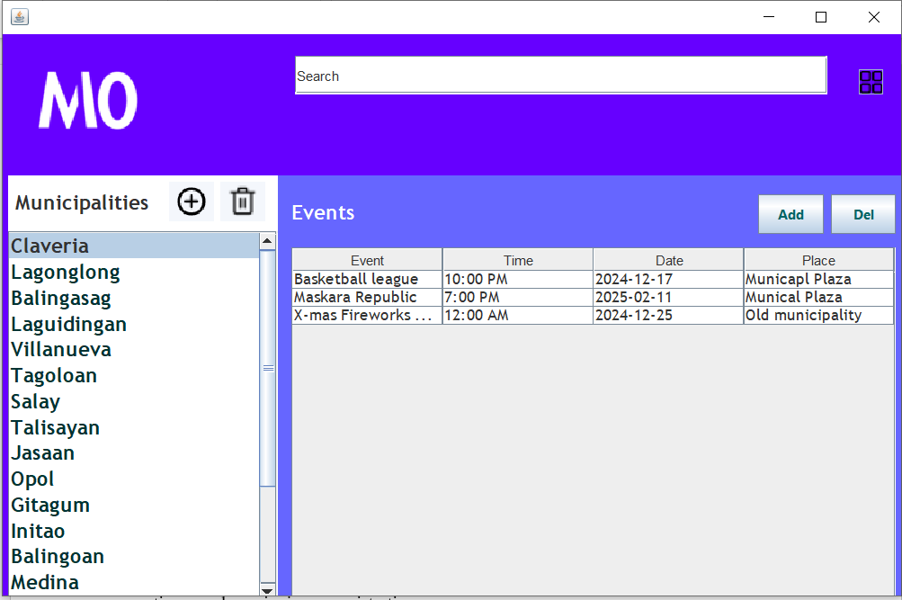

Figure 14: Event Feed Admin Side

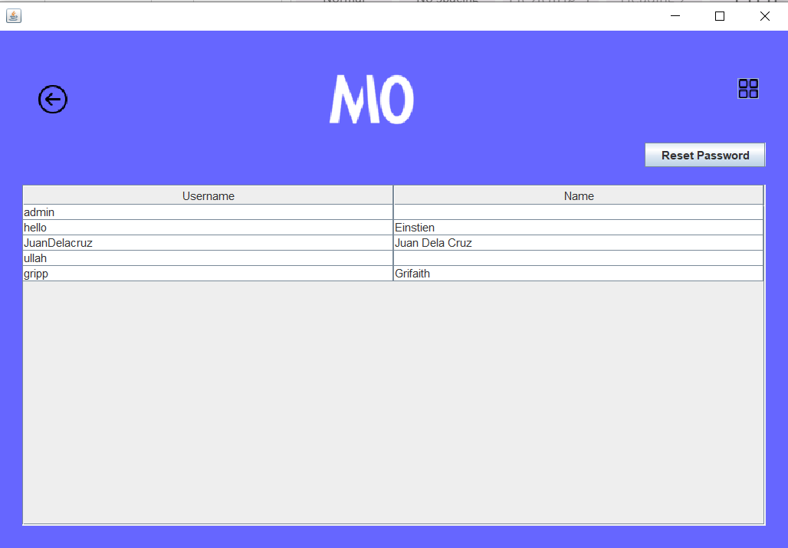The admin dashboard for MIO is a comprehensive and user-friendly interface designed to efficiently manage events and municipalities. It offers robust event management capabilities, enabling administrators to effortlessly create, edit, and delete events while providing detailed information such as dates, locations, descriptions, and categories to ensure accuracy and consistency.

Figure 15: User Account Panel

The admin side of MIO incorporates a secure and efficient system for managing user usernames and passwords, to protect user data and ensure privacy. This system stores usernames and encrypted passwords in a secure database with controlled and monitored access. Administrators can manage user accounts, including resetting passwords, and updating usernames with all changes logged for auditing purposes.

1. **Conclusion**

In conclusion, MIO reflects the region's dedication to celebrating and sharing its rich cultural heritage. The platform serves as a vital resource for both residents and visitors, offering easy access to a wide array of events that highlight the unique charm and traditions of Misamis Oriental. By providing comprehensive and up-to-date information, MIO ensures that users can effortlessly discover and participate in the many cultural festivals, community gatherings, and local activities that define the province. MIO is more than just an event directory; it is a gateway to the experiences that make Misamis Oriental truly special. The platform's user-friendly interface and robust features empower users to navigate and engage with events seamlessly. Whether you're a local looking to stay connected with your community or a visitor eager to explore the province's offerings, MIO provides the tools needed to fully immerse yourself in the vibrant life of Misamis Oriental.

1. **Recommendation**

To enhance the functionality and accessibility of the municipal events application, it is recommended to develop a robust server infrastructure capable of supporting multiple users concurrently, ensuring seamless and efficient coordination across various departments. Expanding the scope of the application to encompass a broader range of services and activities will provide a comprehensive solution that effectively addresses the diverse needs of the community. Additionally, the introduction of a mobile version will increase accessibility, allowing users to engage with the application conveniently and in real-time, regardless of their location. The integration of a calendar feature will further optimize event planning and management, enabling users to track, schedule, and receive timely updates on municipal events. These enhancements will significantly improve the application's utility and overall user experience.